Storage Device | Size | Description | Advantages | Disadvantages
Hard Disk  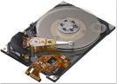 | 120GB - 2TB | Stores data | Large storage capacity, data mirrored so if one disk is damaged another one can take over | If damaged, whole hard drive is corrupted.
Floppy Disk  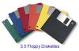 | 1.44 MB | Stores data, first type of storage. | Cheap | Small storage capacity, easily destroyed,
Zip Drive  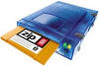 | 100MB | Stores data, was replacement for floppy disk. | Good for larger amounts of data | New drive, bigger disks, expensive, drives easily damaged.
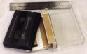  Magnetic tape backup | Over 100GB | Tape that holds data from servers | Hold a lot of data | Sequential storage
CD-ROM  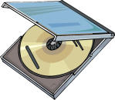 |  | CD you can only use once. | Cheap | Read only, whatever is on it stays on it.
CD-RW  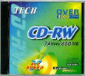 |  | CD you can use more than once to transfer data to. | Write, re-write and record new data. | Easily damaged.
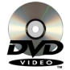  DVD | 4.7GB | Digital Versatile Disk | Cheap | Special software to write.
Flash Memory Stick  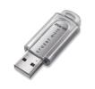 | 64 GB | Small, USB plug | Hold lots of data, no need for special software.  Small, USB | Easily breakable, small so can get lost
ROM 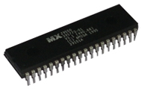 |  | ROM found on motherboard. | Non volatile, stores information forever | Can’t edit the ROM after it has been programmed
RAM  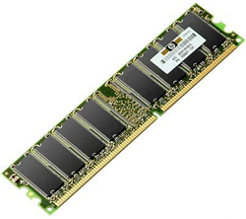 | 1 – 4 GB | Found on motherboard | More RAM means programmes run faster and simultaneously. | Loses data when switched off. Volatile.

